**Executive Summary**

**Problem Statement**

Identifying the trends, patterns, and causes of automobile accidents, requires raw data to be gathered from various sources and analyzed then presented in different reports with preferred criteria.

To get an accurate picture regarding the various factors affecting automobile accidents, a significantly huge amount of data will need to be accessed and utilized effectively.

**Proposed Solution**

Our team will be designing software with the purpose of performing data analysis and visualizing the information regarding fatal injury and crashes involving automobile.

The software will have the following features:

* A database of fatal injury and crashes that occurred in a location over a period.
* Graphical representation of various statistics regarding the crashes based on user requirements.
* Use of keywords present in the data to recognize patterns behind crashes.
* Analyze the impact of human factors like alcohol consumption, driving qualifications, etc.

**Result**

Our team has successfully designed software …………. keeping our problem statement and proposed solution in mind. We were successfully able to build a database with fatal crashes that happened in the state of Victoria. The software will enable the users to access various reports generated with the information stored in the database. We were also able to add the feature of graphical illustration of various statistics based on the user needs.

**Option 1:** For a user-selected period, display the information of all accidents that happened in the period.

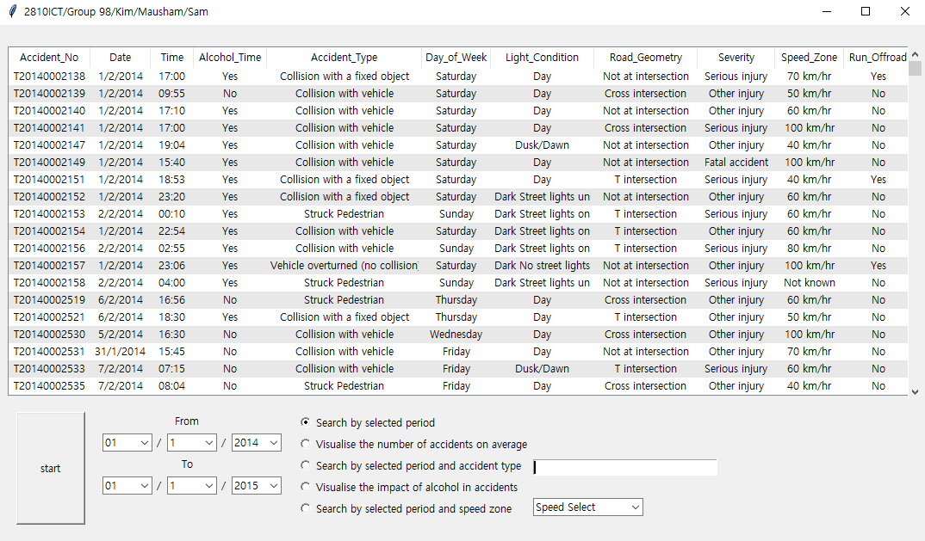

**Option 2:** For a user-selected period, produce a chart to show the number of accidents in each hour of the day (on average).

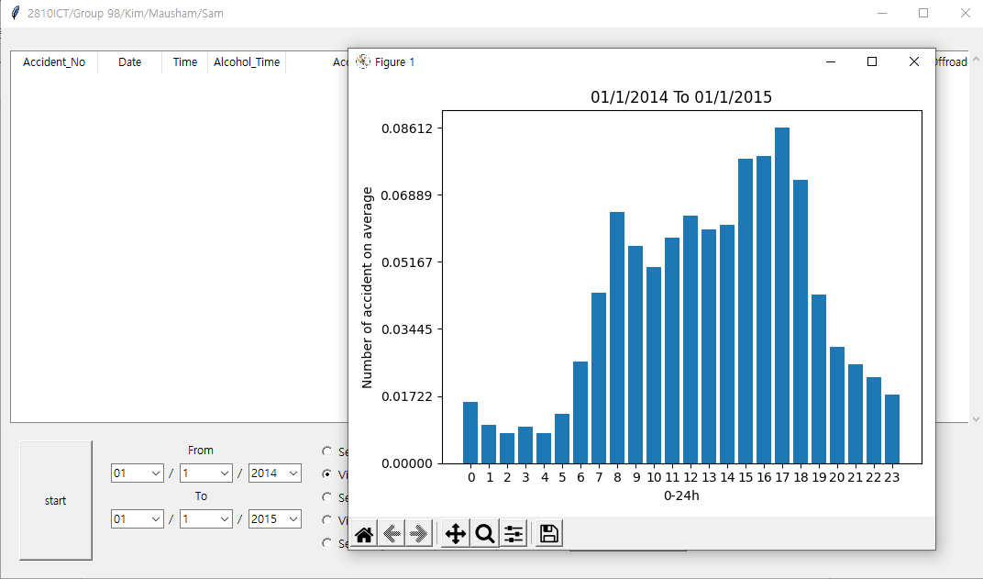

**Option 3:** For a user-selected period, retrieve all accidents caused by an accident type that contains a keyword (user entered), e.g., collision, pedestrian.

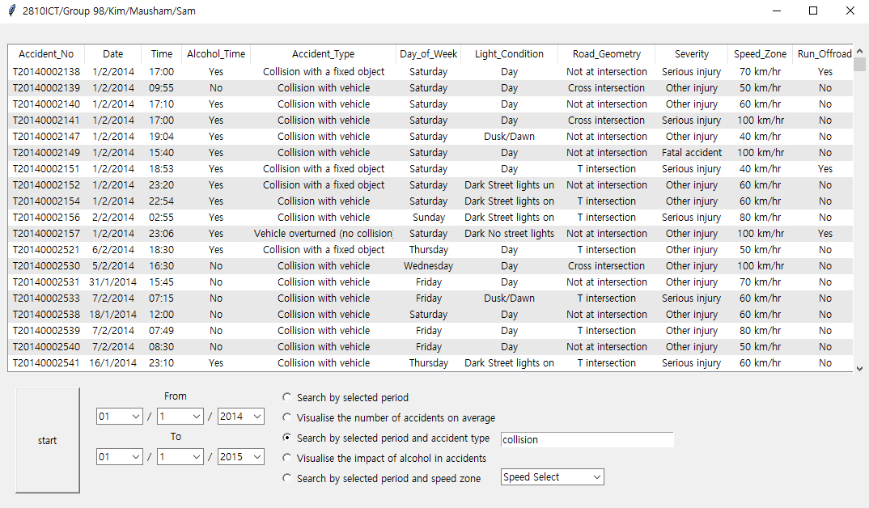

**Option 4**: Allow the user to analyse the impact of alcohol in accidents – i.e.: trends over time, accident types involving alcohol, etc.

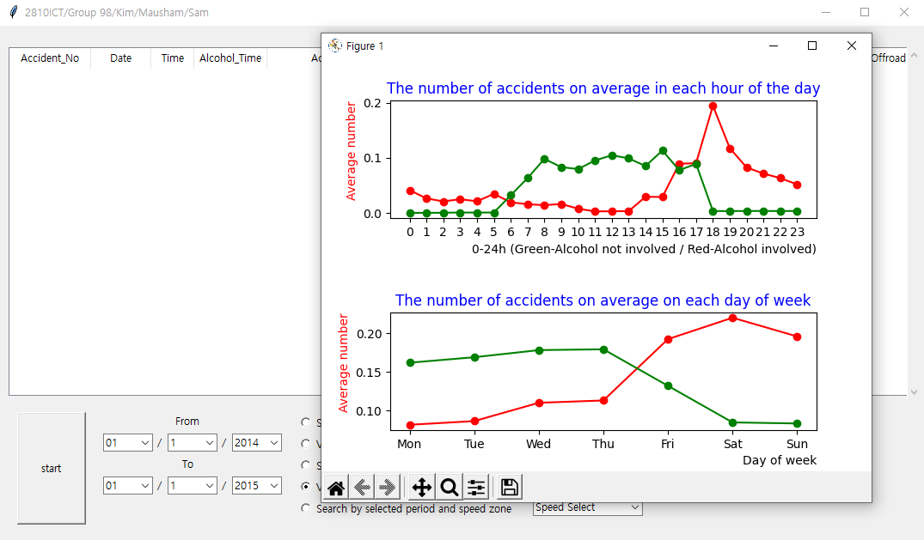

**Option 5:** One other ‘insight’ or analysis tool of your choice

For a user-selected period, retrieve all accidents caused by a speed zone (user chose)

**Values**

Our aim is to not only illustrate the information regarding fatal crashes but also help the users recognize what aspects are crucial and are causing those crashes. This would help the users with access to our software take a cautionary approach to their driving habits and be better drivers.

This software could also be valuable for stakeholders such as automobile companies, insurance companies, government agencies, etc. to set up designs and policies to reduce the ammount of crashes and their fatality.